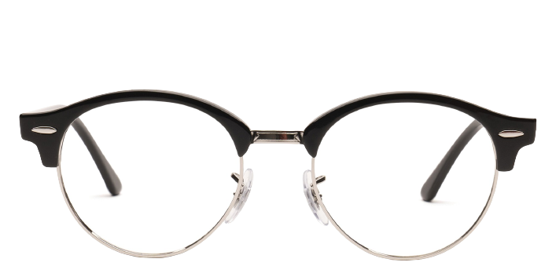 Ray-Ban RX4246V

Product information

|  |  |
| --- | --- |
| **Brands** | Ray-Ban |
| **Gender** | Unisex |
| **Lenses** | Prescription lenses included |
| **Material** | Metakl |

Description

**How can one improve on an icon? Ray-Ban's RX4246 Round Clubmaster shows us how. With a rounded acetate top and lightweight metal rim, this style tops off any look perfectly, whether it's your formal wear or around the house sweat suit.**

|  |
| --- |
| What You’ll Get   * **Thin and light tinted prescription lenses.** * **Soft case and cleaning cloth.** * **Unconditional 30 days return policy. Free return shipping.** |